Triangle Inequality Violations Reveal Context-Dependent Relational Re-Representation in a Large Language Model
Anonymous Authors

Triangle Inequality Violations Reveal Context-Dependent Relational Re-Representation in a Large Language Model
Anonymous Authors

Abstract
Analogical reasoning depends on recognizing when different pairs instantiate the same relation. Vector-space accounts explain this ability by representing relations as difference vectors in a fixed metric space. On this view, relational similarity judgments should satisfy triangle inequality. Behavioral work, however, has shown selective violations of triangle inequality when an ambiguous pair is compared across different relational contexts. These findings suggest context dependence, but they do not reveal whether the effect arises from response bias or from a genuine change in representation. We test this question in Llama-3.1-70B, a vector-based system whose internal states can be examined directly. We compare consistent cases, in which all comparisons instantiate the same relation, with mixed cases, in which an ambiguous pair participates in different relations across comparisons. The model reproduces the human asymmetry: triangle inequality is largely preserved in consistent cases but systematically violated in mixed cases. To probe the source of this effect, we analyze condition-specific function vectors during in-context learning and project them into a shared PCA space. In mixed contexts, the representation associated with the ambiguous pair does not remain fixed, but shifts toward different relational directions as sequential context changes. These results suggest that the violation reflects context-sensitive re-representation rather than a stable relational geometry with a biased readout.

Introduction
Analogical reasoning depends on mapping common relations across superficially different pairs. Whether those mappings reflect stable relational representations or context-sensitive reconstruction is especially important for vector-space accounts of analogy. These accounts explain analogy by representing relations geometrically, often as difference vectors (Shepard, 1987), and typically assume that each pair has a single context-invariant representation. On that view, triangle inequality provides a useful constraint: if relational similarity is derived from fixed positions in a metric space, the constraint should hold. However, human judgments can violate triangle inequality (Tversky, 1977), and analogous violations in relational similarity arise especially in mixed-relation triangles, where one pair can participate in different relations across comparison contexts (Peterson et al., 2020). Behavioral data alone cannot determine whether this pattern reflects response-level bias or a genuine change in the underlying representation. Large language models provide a useful testbed because they allow behavior and internal states to be examined within the same vector-based system (Todd et al., 2024). We therefore ask whether Llama-3.1-70B shows the same context-dependent pattern, and whether any such violation is accompanied by systematic shifts in the model’s internal representation of the same pair across contexts.
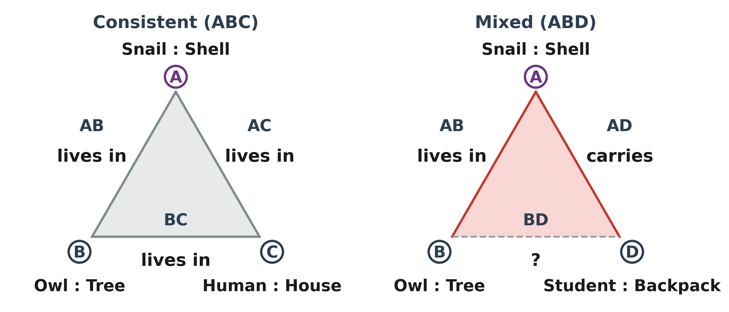
Figure 1. Stimulus design. Each item contains four pairs (A, B, C, D). Pair A is ambiguous and defines a consistent triangle (ABC, left) where all edges share the same relation, and a mixed triangle (ABD, right) where A participates in different relations across comparisons.

Methods
The human experiment included 30 participants and 12 analogy items, each containing four pairs labeled A, B, C, and D. Pair A was ambiguous, pair B shared one relation with A, pair D shared the other, and pair C served as a consistent control, yielding a consistent triangle (AB, AC, BC) and a mixed triangle (AB, AD, BD). Human participants judged the relational similarity of simple black clipart pairs on a 7-point Likert scale, with mirrored comparison orders included to reduce order effects. Triangle inequality was assessed with a symmetric product test (Peterson et al., 2020), with values above 1 indicating violation. We rendered the same item structure as text word pairs and evaluated it in Llama-3.1-70B using in-context Q/A prompts. In a pure/base five-edge design, AB, AC, and AD were scored after A-family demonstrations, whereas BC and BD were scored after B-family demonstrations, directly mirroring the two human triangles. Each edge was evaluated across multiple shot conditions (1, 3, 5, 7, and 9 demonstrations), with the queried pair excluded from the demonstrations so that scores reflected in-context generalization rather than copying. The first-token log-probability of the correct target completion was normalized within each question using a robust min-max transform (5th-95th percentile, pooled across edges and shot conditions) before computing product-test values for the consistent and mixed triangles.
To test whether this asymmetry was accompanied by a change in internal representation rather than response bias alone, we conducted a separate internal-state analysis across pure and interleaved in-context conditions (AAA, BBB, BABA, DDD, and DADA). Using a fixed head set derived from prior activation-patching analyses, we extracted for each trial a summed residual contribution vector at the model state used to predict the first answer token. Following the function-vector framework (Todd et al., 2024), we pooled these trial-level vectors across conditions, fit a common PCA space, and summarized each condition by its centroid in that shared space.
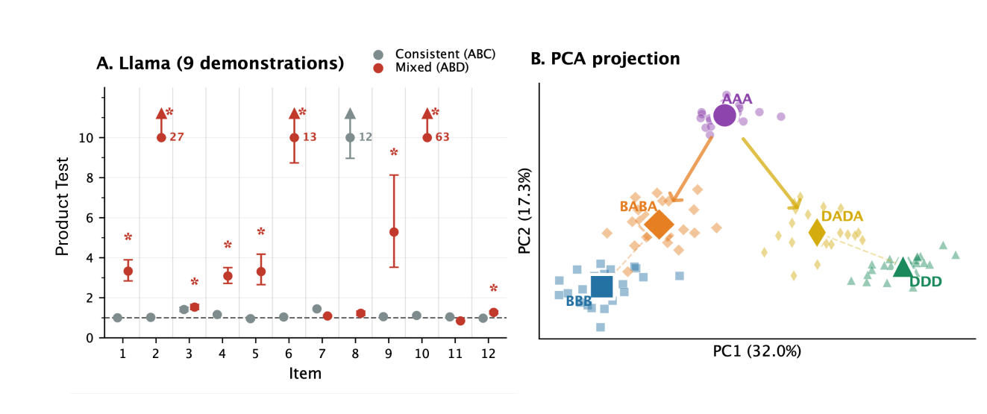
Figure 2. LLM behavioral and representational results. A. Llama-3.1-70B with 9 in-context demonstrations shows higher mixed-triangle than consistent-triangle product-test values across multiple items. B. In a shared PCA space (Q8), interleaved conditions shift toward different relational directions.

Results
Across the same 12 items, human judgments reproduced the established asymmetry: the consistent triangle showed no reliable violations, whereas the mixed triangle showed reliable violations in 6/12 items under a bootstrap criterion (P(PT_ABD > 1) >= .95). In the 9-demonstration analysis shown in Figure 2A, Llama-3.1-70B exhibited the same directional asymmetry at the within-item comparison level: PT_ABD significantly exceeded PT_ABC in 9/12 items (Delta PT > 0, P >= .95). The remaining three items showed the opposite pattern, and no item showed no reliable difference between the two triangles. Thus, the model reproduced the human tendency for mixed-triangle structure to yield larger product-test values than the consistent control.
The representational analysis showed a corresponding context-dependent pattern. Figure 2B shows Q8 as an illustrative example (PC1 = 32.0%, PC2 = 17.3%). In the shared PCA space, pure conditions formed separated centroids, whereas interleaved conditions shifted the ambiguous pair toward different relation-specific endpoints: BABA lay between AAA and BBB but closer to BBB, whereas DADA shifted from AAA toward DDD. Qualitatively similar endpoint-directed reconfigurations were observed across items. The ambiguous pair therefore did not remain at a fixed representational location, but moved with sequential context.

Discussion
These findings argue against assuming a fixed representation for each pair in standard vector-space accounts. The critical issue is not that vector geometry cannot support relational similarity, but that context can dynamically reconfigure the relevant representation before similarity is read out. This does not treat LLMs as direct models of human cognition; rather, it tests a core assumption of vector-space accounts in an explicit vector-space implementation. For cognitive modeling, the implication is that relational similarity may require context-dependent representational updating, not only static geometric readout.

References
Peterson, Joshua C., Di Chen, and Thomas L. Griffiths. 2020. “Parallelograms Revisited: Exploring the Limitations of Vector Space Models for Simple Analogies.” Cognition 205: 104440. https://doi.org/10.1016/j.cognition.2020.104440
Shepard, Roger N. 1987. “Toward a Universal Law of Generalization for Psychological Science.” Science 237(4820): 1317-1323. https://doi.org/10.1126/science.3629243
Todd, Eric, Millicent L. Li, Arnab Sen Sharma, Aaron Mueller, Byron C. Wallace, and David Bau. 2024. “Function Vectors in Large Language Models.” arXiv preprint arXiv:2310.15213. https://doi.org/10.48550/arXiv.2310.15213
Tversky, Amos. 1977. “Features of Similarity.” Psychological Review 84(4): 327-352. https://doi.org/10.1037/0033-295X.84.4.327

